## Lab 4-01: Creating a Storage Account

### Service Introduction

Azure Storage Account is a foundational service within the Microsoft Azure cloud platform, designed to provide scalable and secure storage solutions for a variety of data types. It offers a range of storage services, including Blob storage for unstructured data, Table storage for NoSQL data, Queue storage for messaging between application components, and File storage for traditional file shares. Azure Storage Account ensures high availability and durability by replicating data across multiple data centers, offering options such as locally redundant storage (LRS), geo-redundant storage (GRS), and zone-redundant storage (ZRS). It supports both hot and cool storage tiers, allowing users to optimize costs based on their data access patterns. With features like Azure Storage Explorer for easy management, encryption at rest, and robust access controls, Azure Storage Account provides a reliable and scalable foundation for building cloud-based applications and services.

### Problem

John has an organization for which he wants storage in Azure Cloud to store essential documents. Which storage option can he used to store the documents?

### Solution

By using Azure Storage, he can store his organization’s vital documents.

1. Log in to the **Azure** portal and go to the **“Storage Account”** service.

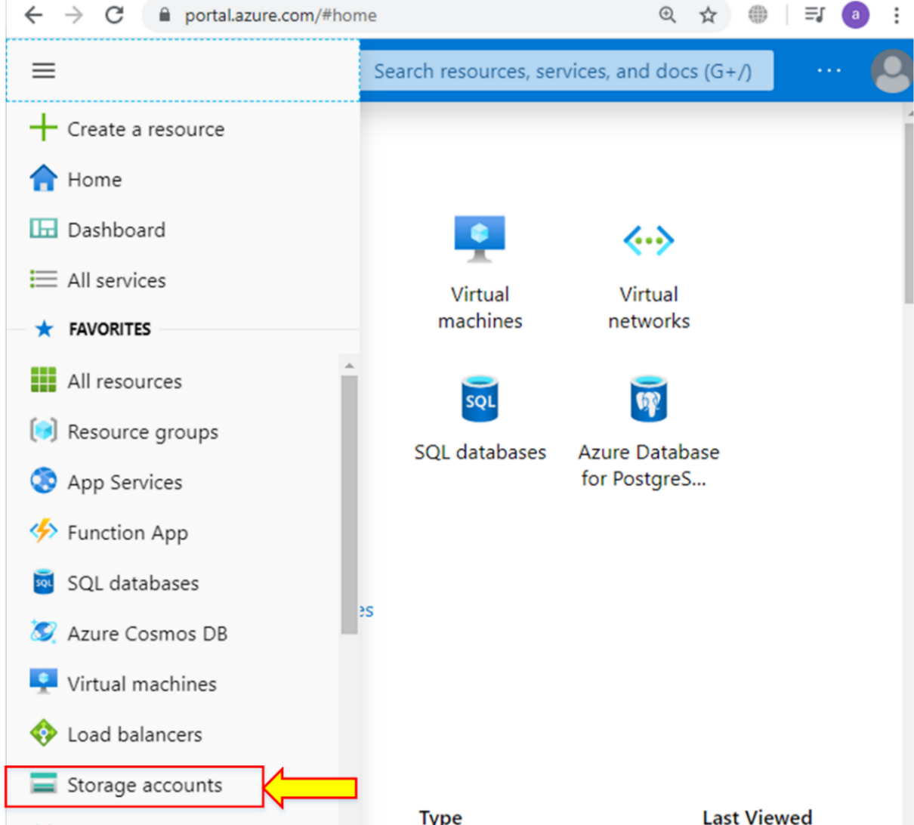

1. Click **“Add.”**

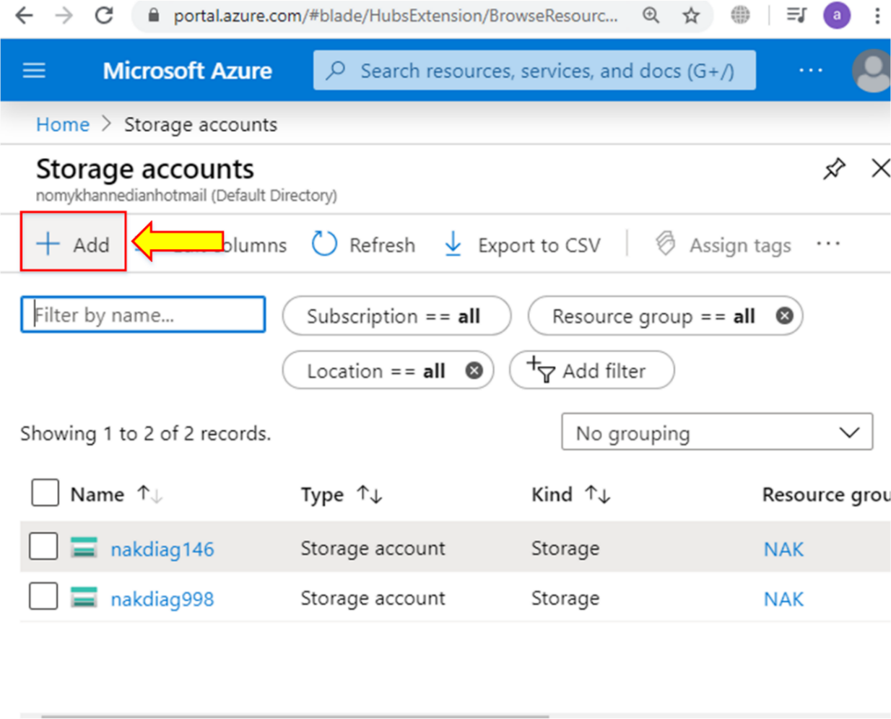

1. Select your subscription and go to “**Create new”** in the resource group option.

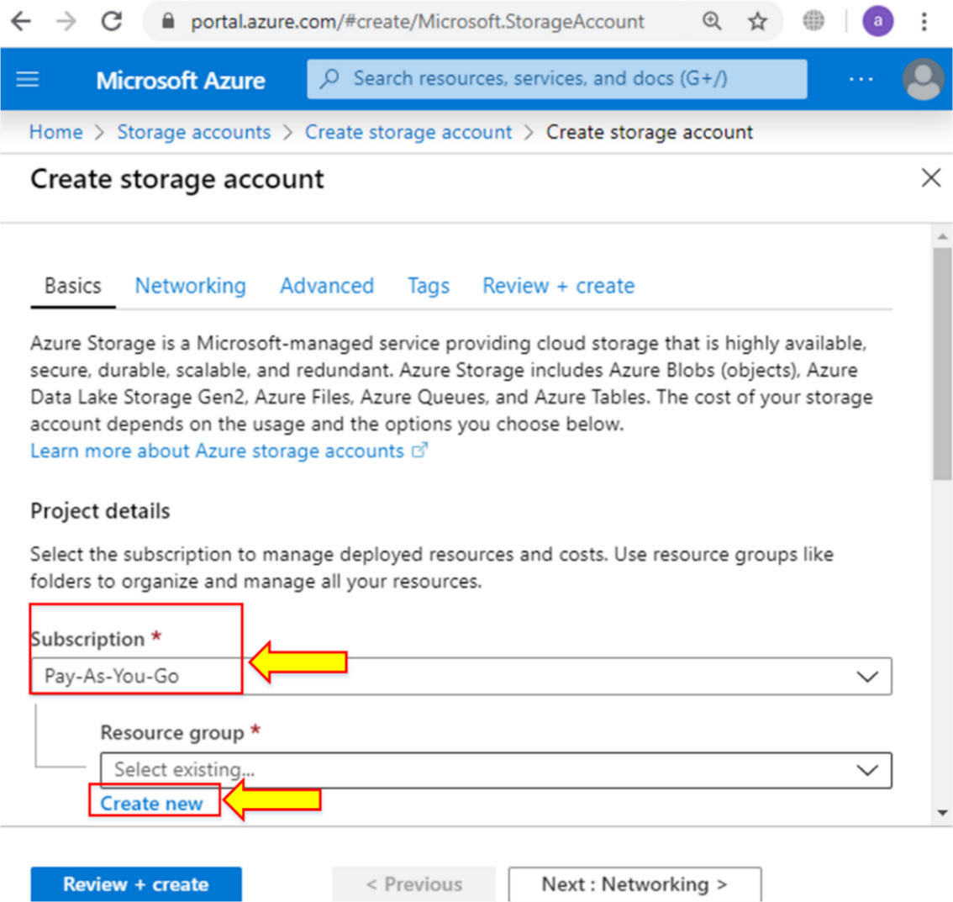

1. Enter the name of the resource group and click **“OK.”**

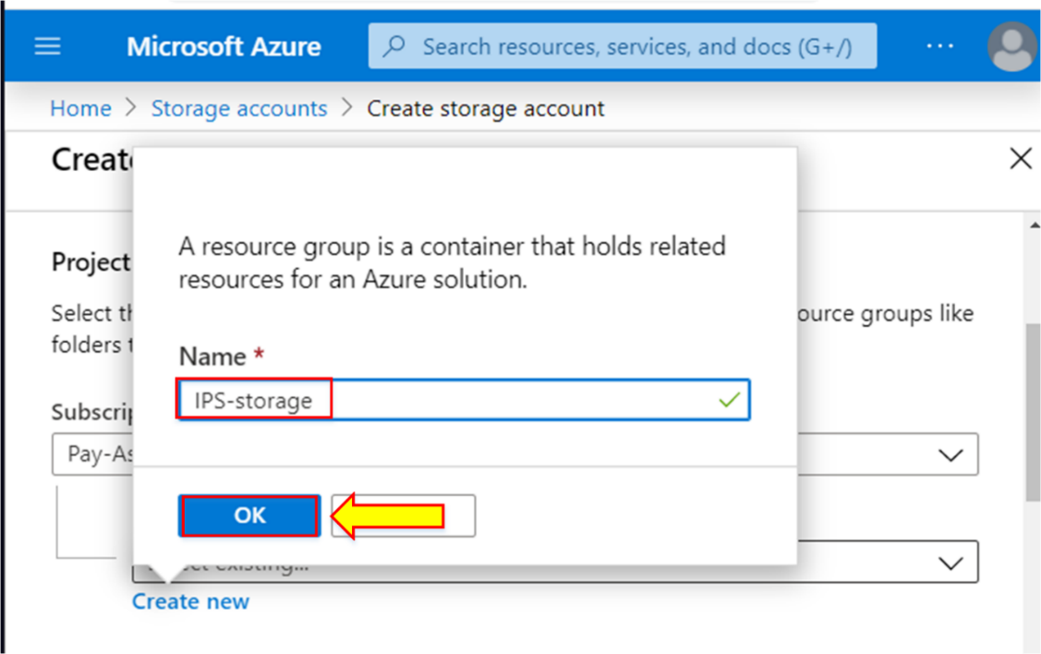

1. In the instance detail, enter “**Storage account name**” (the name should be lowercase).

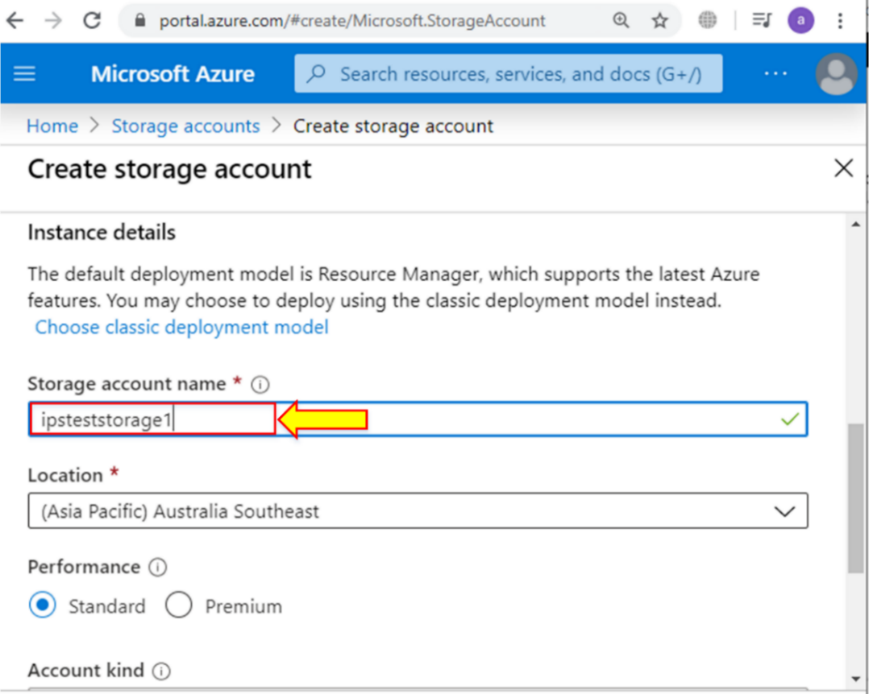

1. Leave everything else by default and click on “**Review + create.”**

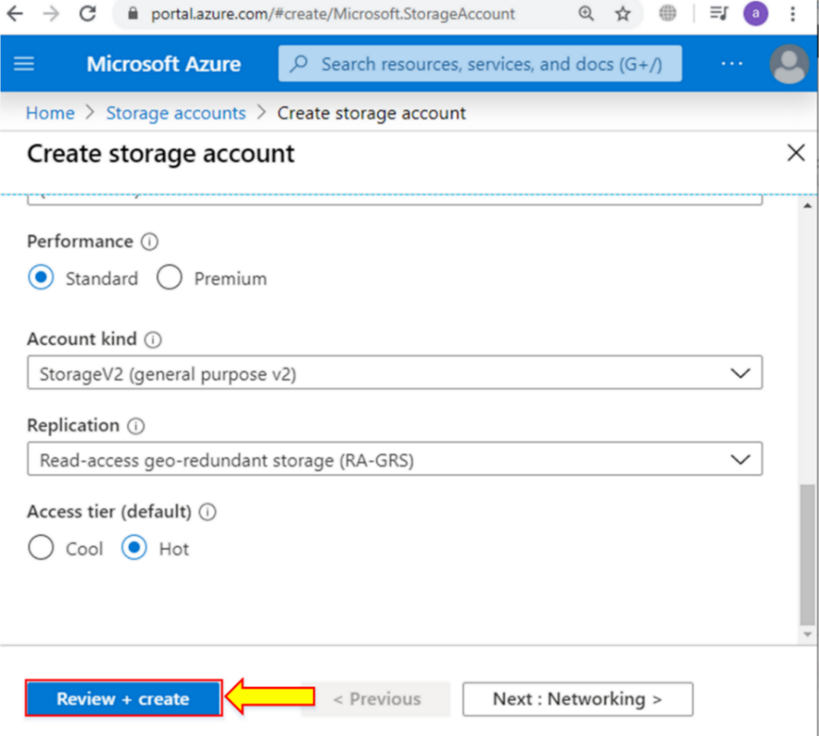

1. Click “**Create.”**

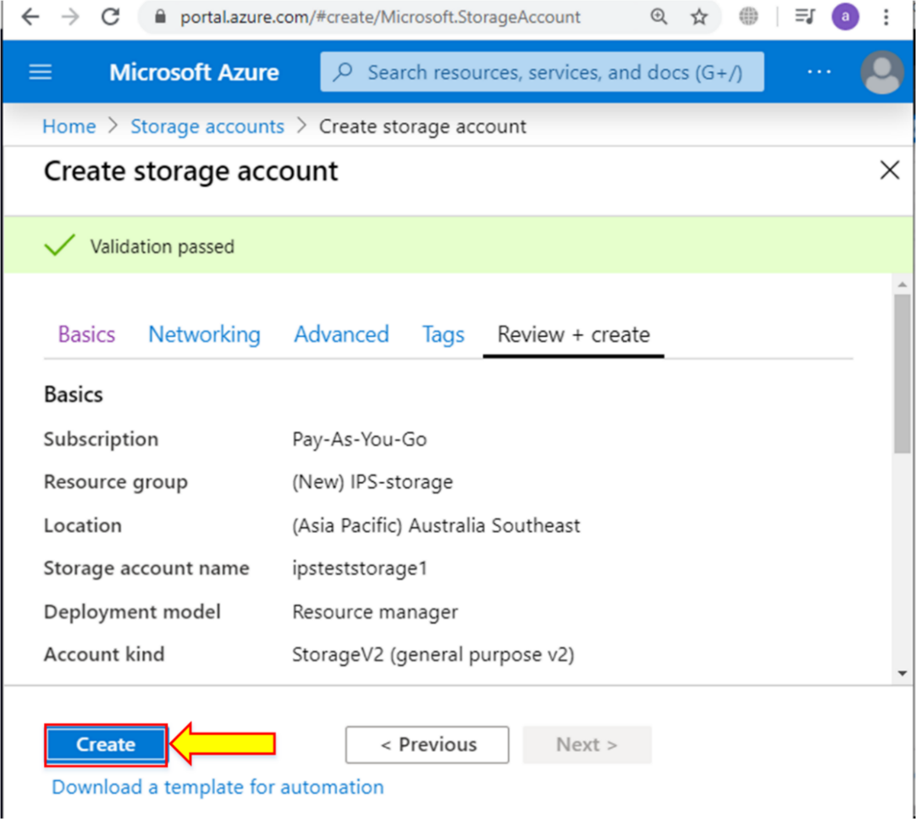

1. Now your storage account has been deployed. Go to “**Deployment details.”**

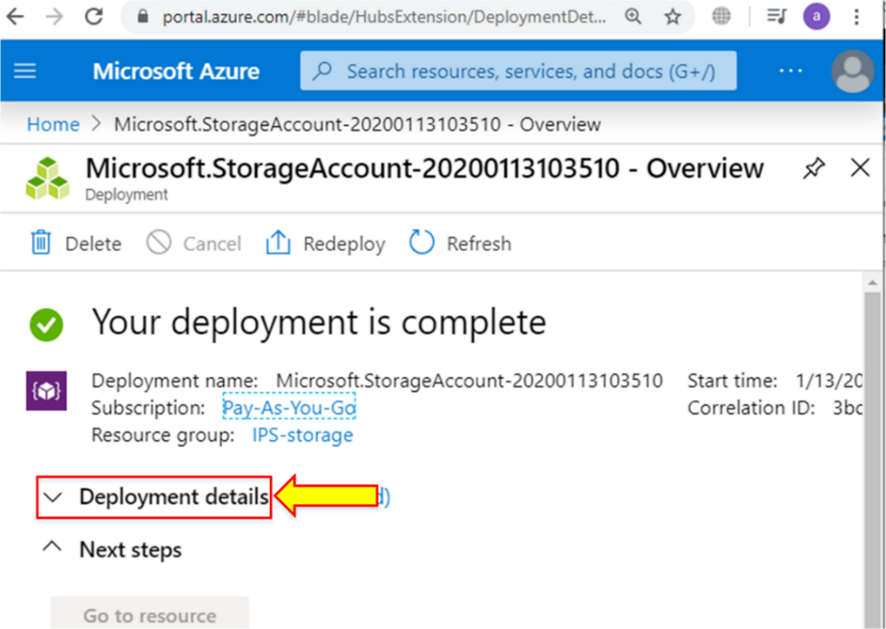

1. Click on the resource that you created. You will see the overview of the storage account.

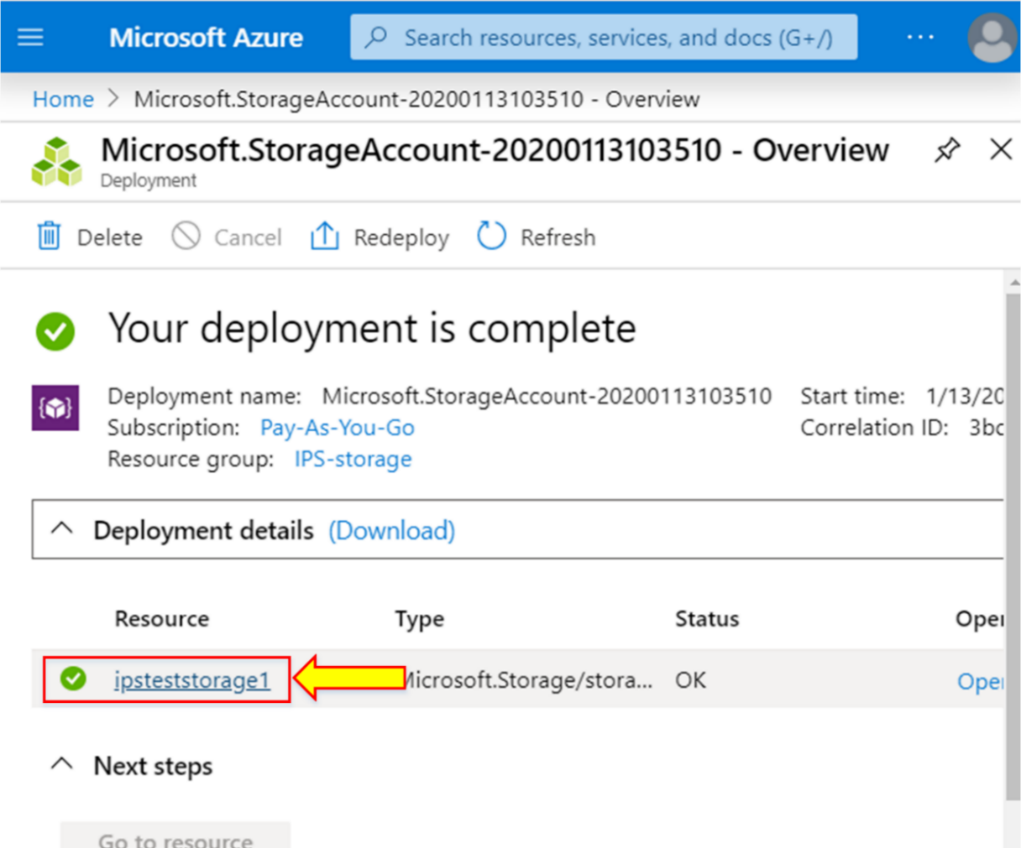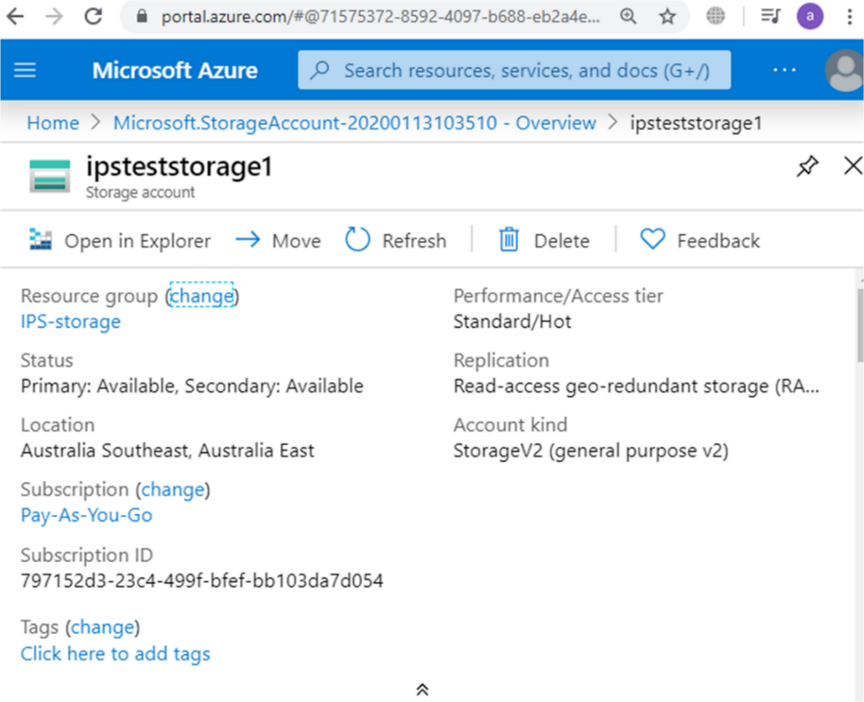

1. Now, you will see the service option, where you get multiple storage options.

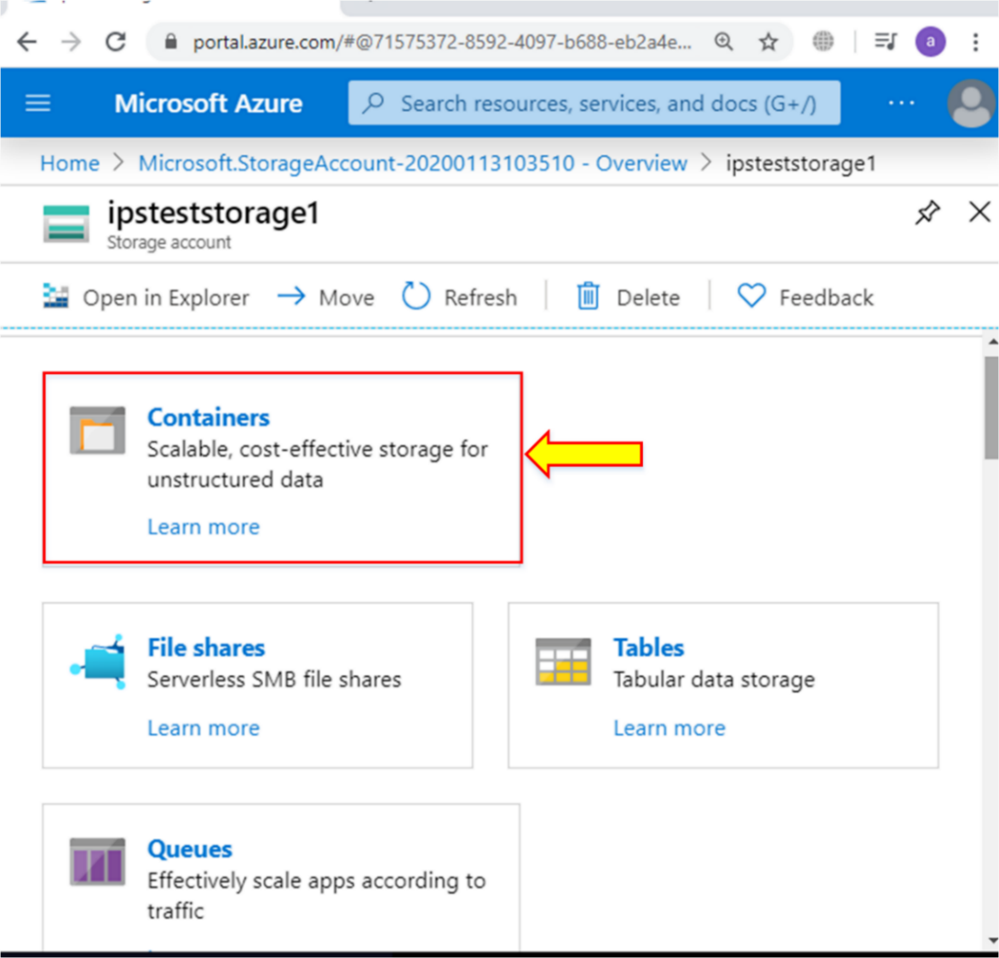

## Lab 4-02: Create a Storage Blob

### Service Introduction

MediaStream, a rapidly growing streaming service provider, faced a critical challenge: their on-premises storage system couldn't handle the explosive growth of user content and video libraries. Lagging playback, buffering, and server crashes threatened their reputation and user experience.

### Problem

MediaStream's existing storage infrastructure couldn't keep up with the rising volume of video content uploaded by users and creators. This led to frequent capacity bottlenecks and performance issues.

### Solution

Recognizing the necessity for a robust and scalable solution, MediaStream partnered with a cloud provider to migrate their entire video library and user content to Azure Blob Storage. Azure Blob Storage effortlessly scales to accommodate any video content volume, eliminating capacity constraints and future worries about growth.

|  |
| --- |
| Task 1: Create a Storage Account  1. Sign in to the Azure portal.      1. Select **Create a resource**.      1. Under Categories, select **Storage**.      1. Under Storage account, select **Create**.      1. On the **Basics** tab of the Create a storage account blade, fill in the information. Leave the defaults for everything else.      1. On the **Advanced** tab of the Create a storage account blade, fill in the information. Leave the defaults for everything else.      1. Select **Review** to review your storage account settings and allow Azure to validate the configuration.      1. Once validated, select **Create**.    Task 2: Work with Blob Storage  1. Under Data storage, select Containers.      1. Select + Container and complete the information.      1. Select Create.      1. Back in the Azure portal, select the container you created, then select Upload.      1. Browse for the image file you want to upload. Select it and then select upload.      1. Select the Blob (file) you just uploaded. You should be on the properties tab.      1. Copy the URL from the URL field and paste it into a new tab.    Task 3: Change the Access Level of your Blob  1. Go back to the Azure portal. Select Change access level.      1. Set the Anonymous access level to Blob (anonymous read access for blobs only).      1. Select OK.      1. Refresh the tab where you attempted to access the file earlier. |